AWSVPCB Setup Instructions

PART 1: AWS Personal Account Creation Instructions
Steps 1-9 walk you through creating a personal AWS account. If you already have an account, you can skip to #10.
- Go to https://aws.amazon.com/console/ Or Google “AWS Console”
- Click on “Create an AWS Account”
- Fill out your information using your personal email address, and then continue (REMEMBER TO NOTE THE PASSWORD YOU SELECTED):
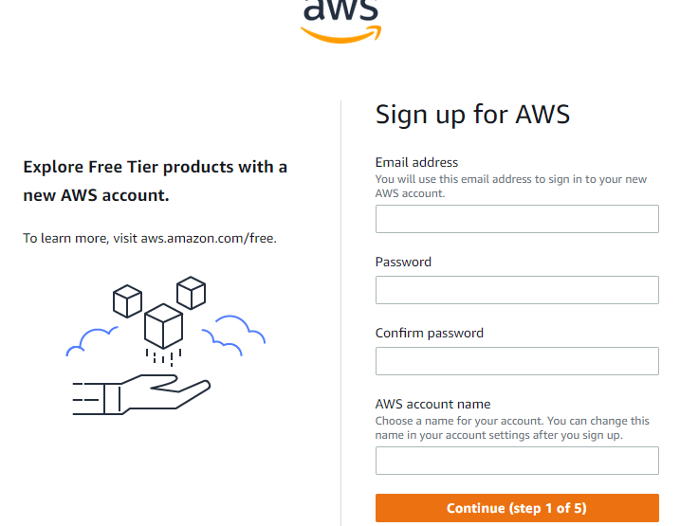
- Select “Personal” and then fill out the Contact Information, and other details as needed; then click “Continue”.
- You then need to provide payment information and click “Verify and Continue”.
- You will then be prompted to confirm a captcha and provide verification of receipt of an SMS message.
- You then need to select your support plan – choose the “Basic Plan”, which is free.
- Finally, click on “Sign into the Console” button.
- Enter in your userid and then password to login

PART 2: Create AWS user for scripts
- At the main AWS console, click on “Services” on the top banner to expand the full list
- Type in “IAM” and click on the selection that appears underneath (IAM – Manage access to AWS Resources)
- Click on “Users:”
- Click on the “Add user” button
- Choose a username of your liking, then click on the “Programmatic access” checkbox and then the “Next: permissions” button. This user will be used to connect to AWS via the CLI to populate your environment.
- On the next screen, click on the “Attach existing policies directly” button and select “AdministrativeAccess”
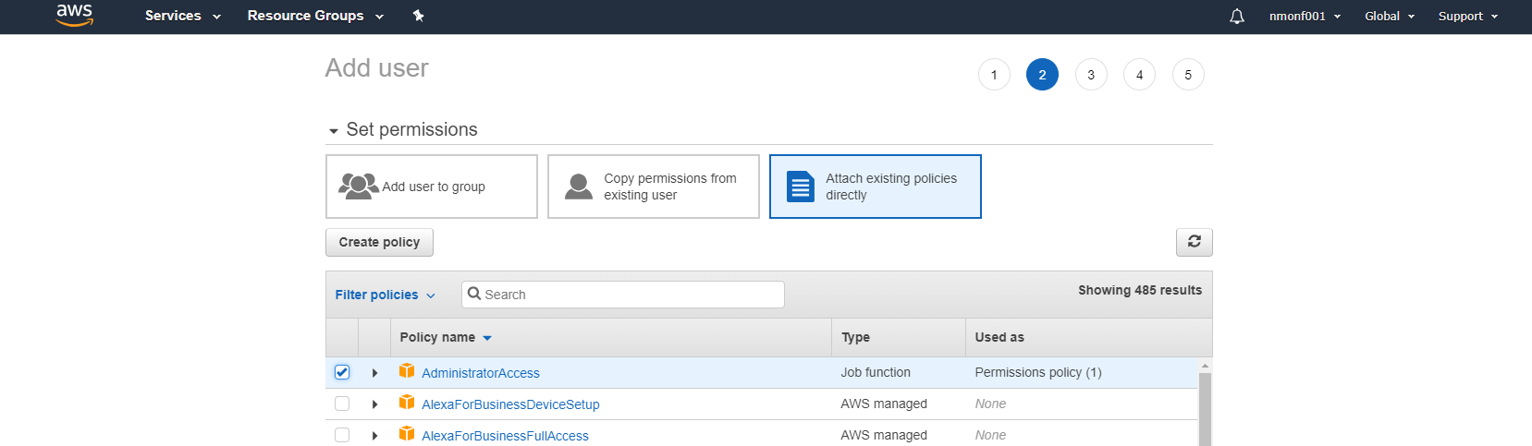
- Click next twice and then click the “Create user” button
- IMPORTANT: On the next screen, you will be provided with the user’s “Access key ID” and “Secret access key” – save these off NOW. You will not see these again and you need them in order to configure the AWS CLI. If you lose these, you are allowed to create new ones whenever you’d like.

PART 3: AWS CLI Setup:
Now that you have your AWS Account, it’s time to setup your AWS CLI (command line interface) such that you can utilize the scripts we will provide to build your assignments. The following steps walk you through this.
BACKGROUND: The AWS CLI scripts created for CTS-4743 (called AWSVPCB scripts) are written in BASH shell scripting. Thus, you need to run them within a BASH shell. BASH shells are available on Linux, MacOS and even Windows WSL (Windows Subsystem for Linux). However, the AWSVPCB shell scripts are only regularly tested on Linux, so issues may be encountered on MAC and Windows.
AWS CLI Versions: For this course, we will be installing and using AWS CLI version 2 (AWS CLI version 1 is now deprecated).
- Follow these instructions to install the AWS CLI on MAC or a Linux system: https://docs.aws.amazon.com/cli/latest/userguide/getting-started-install.html
- If the default shell for your Linux system is NOT bash, then you need to change your shell to bash. In order to do this, simply type the following command: bash
  - Please note that you will need to do this every time you login or add it the login rc file for your default shell.
- Test out the AWS CLI by issuing the following command, then take a screenshot of it and the output: aws --version
- Now, you need to configure the AWS CLI for your account by running the following command: aws configure
- Enter in your Access Key, then your Secret Access Key, then us-east-2 for the Default region and json for the Default output
- Now let’s test your access by issuing the below commands:
  - aws iam get-account-summary
  - aws ec2 describe-instances

PART 4: Install & configure AWS-VPCB scripts and create your AWS environment:
This first set of instructions focus on installing and configuring the AWS-VPCB scripts. These scripts will be used in every assignment to setup and breakdown your AWS environment for that particular assignment.
- Download the AWSVPCB-Scripts directory on the Linux machine where you installed and configured the AWS CLI. You can use this link-> https://github.com/clouducate/awsvpcb/raw/main/awsvpcb-scripts.zip
- Extract the zip file and note the directory
- Change directory (cd) into the awsvpcb-scripts directory
- Run the following command: bash
- Run the following command: chmod 700 *
- Run the following command: chmod 700 procs/*
- Run the following command: ls -al
  - This should show you all of the core scripts that you can run. There are sub-procedures within the “procs” directory and you are free to look at them all, but they are not able to execute on their own. Only the AWSVPCB scripts in the root directory are meant for direct execution.
- From the root directory of the scripts, run the following command: ./AWSVPCB.CONFIGURE
- From the root directory of the scripts, run the following command: ./AWSVPCB.TEST

PART 5: Adjust and create your environment
Once the scripts are loaded and your VPC is created, you can then adjust your assignment as needed. Three assignments are preloaded and assume that you wish to use a VPN, however, this can be altered to use a Bastion host instead. The full system documentation can be found here -> https://github.com/clouducate/awsvpcb/raw/main/AWSVPCB%20Documentation.pdf

- If you wish to adjust any settings, you can navigate to the “secfiles” directory. There are directories for the creating of the VPC (vpc*) and each assignment (assignment*). The vpc0 (default) VPC configuration is has been pre-created with the BASTION host option, while the vpc1 VPC configuration is pre-created with the VPN option. In addition, assignment1-3 is pre-created with fully functional applications in multiple configurations. If you wish to adjust any options, these are the directories where to do so. You can create new directories with different number vpcs or assignments as well. Once ready, move on to next steps.
THE REST OF THESE STEPS ASSUME THAT YOU WILL BE USING THE “BASTION HOST” OPTION. IF YOU WISH TO USE THE “VPN” OPTION, PLEASE REFER TO THE DOCUMENTATION ABOVE.
- From the root directory of the scripts, run the following command: ./AWSVPCB.VPC.CREATE
- From the root directory of the scripts, run the following command to create assignment 1. You can change the number to 2 or 3 to start either of those assignments: ./AWSVPCB.ASSIGNMENT.CREATE 1
- From the root directory of the scripts, run the following command: ./AWSVPCB.ASSIGNMENT.START
IMPORTANT NOTE: Whenever your assignments are in a “started” state, you are spending money. While you are using up a small amount, leaving your assignments in a “started” state 24x7 for hours or days will begin to cost significantly.
- You will see the Public DNS name of the Bastion host appear during the START script. This DNS name will be different every time you perform a START. Record this name so that you can connect to it with RDP over the Internet.
- You will need to go to AWS and adjust the AWS-VPCB-PUBLIC security group’s “inbound rules” your IP address to access this security group on port 3389 (RDP). The easiest way to do this is to add a rule and do the following:
  - Select the “Type” as RDP from the drop down (the default is “Custom TCP”).
  - Select the “Source” as MyIP again from the drop down (the default is “Custom”).
- To log onto the BASTION host, from your PC, start the RDP (Remote Desktop) client. Provide the Public DNS name as mentioned above as the host. The userid is Administrator and the password is located in the IIS.password file in the secfiles directory.
- Download and extract the AWSVPCB-SCRIPTS zip file on this server so that all the security files in the secfiles directory are readily available.

PART 5: Log into your servers

- First, you can connect to the Windows servers. In the secfiles subdirectory, you should see 3 rdp file (iis1.rdp, iis2.rdp and mssql.rdp) – Not all assignments have all servers defined. You can test connecting to these servers as follows:
  - Double-click on the MSSQL.rdp file and then on the “Connect” button.
  - When prompted with the Windows Security dialog for entering credentials, click on “Use another account”.
  - Type in Administrator as the User name.
  - Then open the MSSQL.password file and copy/paste the password in the prompt
  - Click on the “remember my credentials” check box and then hit enter
  - On the next screen, click on the “Don’t ask me again…” check box and then click on the “Yes” button – this should log you into the server
  - If the assignment has an IIS1 or IIS2 server, repeat the above using the appropriate rdp file and IIS.password file instead
- Next, in order to connect to the Linux servers, you have two options:
With SSH
  - cd to the awsvpcb-scripts/secfiles directory on your MAC
  - If on a MAC - Type: chmod 600 privkey.pem
  - Type: ssh -i privkey.pem ec2-user@linux1.awsvpcb.edu
  - When prompted for a passphrase type: cts4743
With PUTTY –
  - Open Putty or equivalent tool
  - In the “Hostname” field enter: ec2-user@linux1.awsvpcb.edu and make sure that the port is 22 and “connection type” is SSH
  - Then expand the “SSH” tab on the left side of the screen, select the “Auth” entry and click on “Browse” as shown below
  - Navigate to the awsvpcb-scripts directory and select the “privkey.ppk” file.
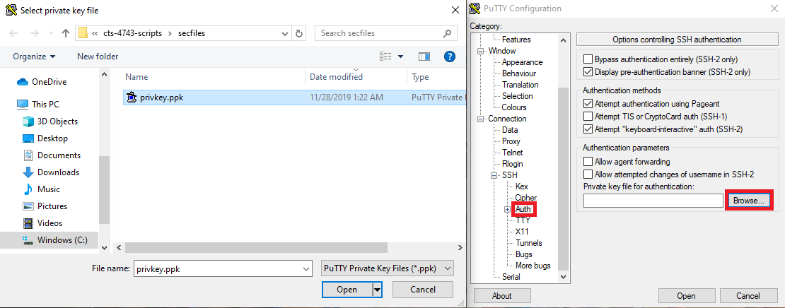
  - Then click on the “Session” tab on the left side of the screen to return to where you started.
  - In the “Saved Session” field, enter linux1.awsvpcb.edu and click “Save”
  - Then double-click on the new entry “linux1.awsvpcb.edu” in the “Saved Sessions” list.
  - This should prompt you to tell you to approve the fingerprint of the new server – click “yes”
  - You will then be prompted with the following - Passphrase for key “imported-openssh-key”:
  - Enter: cts4743
- To get to “root” access on your server, simply type: sudo su -

PART 6: Test your applications:
This following set of instructions are designed to guide you through testing your applications.
ARCHITECTURE:
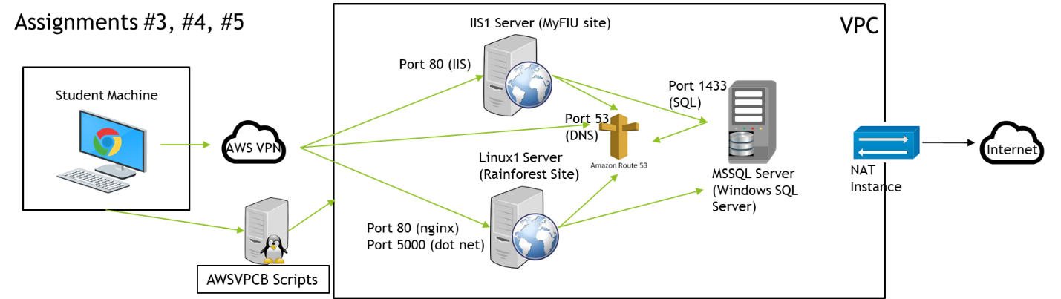

- Open a browser on your BASTION host or PC and type HTTP://rainforest.awsvpcb.edu
- You should be presented with a shopping web site.
- Using Putty (or equivalent tool), login to linux1.awsvpcb.edu then type the below. These are important for troubleshooting in future assignments as it allows you to test the website on the serve itself:
  - wget localhost
  - wget localhost:5000
  - more index*
- Then type the following:
  - cd /var/batch/catalog_exporter
  - rm export/*; dotnet CatalogExporter.dll ; more export/*
- Open a browser on your PC and type HTTP://myfiu.awsvpcb.edu
- You should be presented with a University web site.
- RDP to iis1.awsvpcb.edu and open Chrome within the RDP session. Type localhost in the URL bar in Chrome and the same Contoso site should show up. This is important to note as a troubleshooting tool for future assignments as it allows you to test the website on the server itself!
- Open a CMD prompt and type the following:
  - cd C:\Batch\StudentGenerator
  - StudentGenerator.exe 2500

PART 7: Stop your assignment:
It is critical that you stop each of your assignments when you are going to take an extended break to avoid racking up a lot of AWS charges.
- Go back to your awsvpcb-scripts directory on Linux
- Run the following command: bash
- From the root directory of the scripts, run the following command: ./AWSVPCB.ASSIGNMENT.STOP

